WEEK 3-Assignmet

Chanakya Campus Chatbot
Objective:
To create a chatbot that helps students and visitors:
- Get information about campus locations.
- Check open and close timings.
- Navigate between different locations using shortest paths.
Database Integration:
- All campus locations, timings, and facilities are stored in a database.
- The chatbot fetches information dynamically from the database.
- Easy to update timings or add new locations.
Navigation Integration:
- The chatbot calculates the shortest path between locations.
- Supports walking and vehicle modes.
- Helps users plan efficient routes on campus.
User Interaction:
- Users can choose to check timings or plan travel.
- For timings: Select a location → Bot shows open/close time + Sunday closure.
- For travel: Select start and destination → Bot shows best route and distance.
- Conclusion:
A practical tool for campus visitors combining information access and navigation in one chatbot interface.

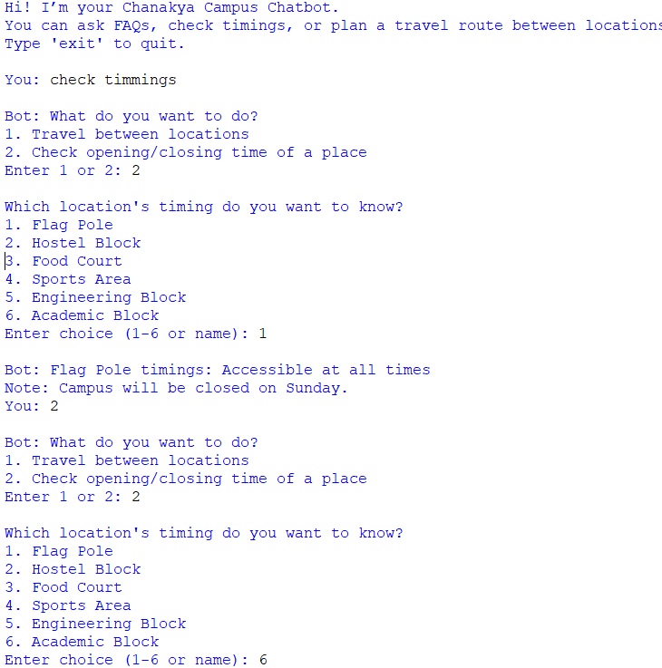

N
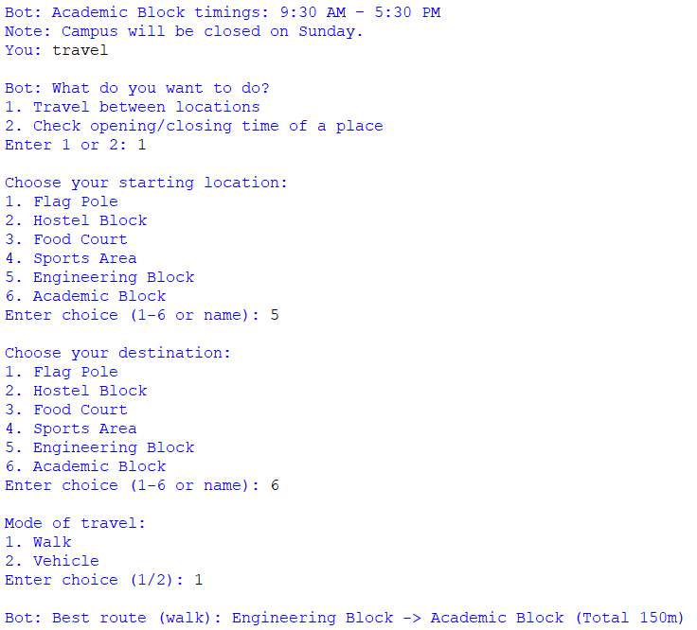
NOTE:code is uploaded in Assignment section -Week 3-Chat bot CODE

